Company Profile
Name | Emaar Properties
Address | Level 7, Dubai Hills Business, Park Building 1, +971 4 366 1688
Experian ID | 12345678
Subsidiaries | Emaar Malls, Emaar Hospitality, Emaar Entertainment, Emaar Technologies, Emaar Commercial Leasing
Branches | Middle east, North Africa, Europe, North America
Ultimate Parent | Emaar Properties
SIC Code | 1520 – Real Estate Construction
Business type | Incorporated
Experian file established | January 1997
Years in business | More than 28 years
Total employees | 500
Date of Incorporation | 2nd October 1997

Experian Credit Score
Business Credit Scores range from a low of 1 to high of 100 with this company receiving a score of 60.
Higher scores indicate lower risk. This score predicts the likelihood of serious credit delinquencies within the next 12 months. This score uses tradeline and collections information, public filings as well as other variables to predict future risk.
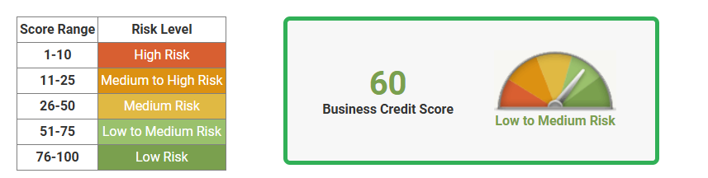
Business Credit Score is calculated by a statistically derived algorithm, designed to determine risk based on multiple factors including:
- Credit: Number of trade experiences, balances outstanding, payment habits, credit utilization and trends over time
- Public Records: Recency, frequency and dollar amounts associated with liens, judgments or bankruptcies
- Demographic Information: Years on file, Standard Industrial Classification (SIC) code and business size

Credit Score Comparisons
Date | Current | Feb’25 | Jan’25 | Dec’24 | Nov’24 | Oct’24 | Sept’24 | Aug’24 | July’24
This company | 60 | 53 | 50 | 65 | 16 | 16 | 16 | 21 | 13
All scored companies | 48 | 47 | 44 | 44 | 44 | 44 | 45 | 45 | 45
Same industry group | 48 | 47 | 48 | 47 | 47 | 47 | 48 | 48 | 47
Same asset size group | 46 | 47 | 48 | 46 | 47 | 48 | 48 | 47 | 46

Comparison Sector: Real estate construction
Asset size group: AED 35,000 to AED 90,000
99

Experian Financial Stability Risk
Financial Stability Risk Ratings range from a low of 1 to high of 5 with this company receiving a rating of 1.
Lower ratings indicate lower risk. Experian categorizes all businesses to fit within one of the five risk segments. This rating predicts the likelihood of payment default and/or bankruptcy within the next 12 months. This rating uses tradeline and collections information, public filings as well as other variables to predict future risk.
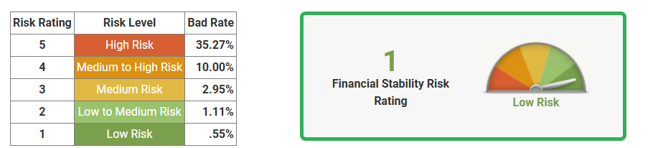

Days Beyond Terms (DBT)
Current Days beyond terms: 60
Average industry days beyond terms: 15
Date | Current | Feb’25 | Jan’25 | Dec’24 | Nov’24 | Oct’24 | Sept’24 | Aug’24 | July’24
Company | 60 | 60 | 15 | 0 | 0 | 0 | 0 | 0 | 0
Industry | 15 | 15 | 15 | 15 | 15 | 15 | 15 | 15 | 17

Credit Utilization
Total Credit Limit of AED 60,000
Available Credit – AED 19673
Credit Line Utilized – AED 40327

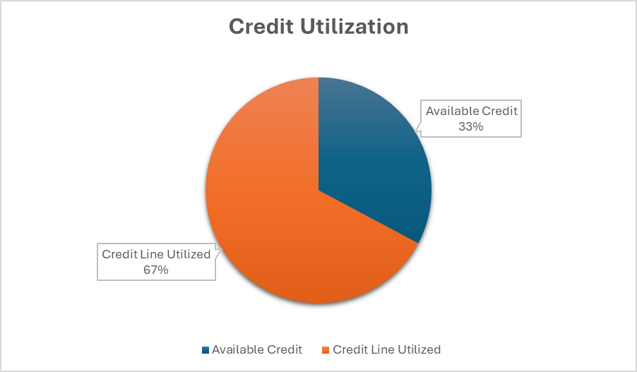

Payment Trends
Monthly payment trends
Date | Balance | Current | 0-30 DBT | 31-60 DBT | 61-90 DBT
Feb’25 | AED 1,346,600 | 98% | 0% | 2% | 0%
Jan’25 | AED 1,476,578 | 99% | 0% | 1% | 0%
Dec’24 | AED 1,345,678 | 94% | 6% | 0% | 0%
Nov’24 | AED 1.568.789 | 100% | 0% | 0% | 0%
Oct’24 | AED 1,322,400 | 100% | 0% | 0% | 0%
Sept’24 | AED 1,245,467 | 100% | 0% | 0% | 0%
Aug’24 | AED 1,065,400 | 100% | 0% | 0% | 0%

Credit Summary
Lowest 6 month balance: AED 1,135,000
Highest 6 month balance: AED 2.500,000
Highest credit amount extended: AED 70,000
Median credit amount extended: AED 3,035,600
Total current account balance: AED 2,467,890

Public Records
Type Status | Number | AED Value | Recent Date Filed
Bankruptcies | 0 | 0 | None reported
Judgements | 1 | 2675 | 11th March 2015
Liens | 0 | 0 | None reported

Judgements:
- Date: 11th march 2015
- Filing location: Dubai
- Legal type: judgement
- Legal action: Filed
- Document umber: 61681
- Liability amount: AED 2675

Additional Information
Alternate Company Names: No information available
Owners and Guarantors Names:
Owner and Guarantor Name | Type | Date reported
John Doe | Guarantor | 10th March 2020
Peter Pan | Guarantor | 2nd February 2023
James Adams | Guarantor | 11th December 2023

Report Generated On: 15th March 2025

